# Topics

1. Newton’s Laws
   1. First Law – If the net force on an object is zero (∑F = 0), the object will not accelerate. It will maintain its state of motion (rest or constant velocity).
   2. Second Law – If the forces on an object are not balanced, it will accelerate in the direction of the net force. Net force and acceleration are directly related, ∑F = ma.
   3. Third Law – Forces come in pairs (actions/reactions). Each force in an action/reaction pair acts on a different object.
2. Free-body diagrams and word problems
   1. Use FBD’s to apply Newton’s 2nd law in horizontal and vertical directions
   2. Analyze a word problem to decide if acceleration in the horizontal or vertical directions is equal to zero
   3. *Honors Physics only* Solve problems with angled forces by breaking them into components

**Answer the Following:**

1. What is the difference between mass and weight? What are their units?
2. What is inertia? What is it related to?
3. What is a force and what are its units? Is it a vector or a scalar?
4. Know the sign of acceleration for an object moving in a positive or negative direction and speeding up or slowing down.
5. When the same force is applied to two objects of different mass, compare the accelerations that result.
6. What two factors affect the force of kinetic friction?
7. Why is the maximum force of static friction greater than the force of kinetic friction?

**Things you need to know how to do (You don’t have to write anything here):**

1. Draw a free body diagrams for an object (which you can use when writing an equation).

1. Apply Newton’s 1st or 2nd law to a given scenario to determine forces and accelerations.
2. Draw the normal force and weight in the appropriate directions and strengths on a free body diagram.
3. *Honors only* Break a force vector into components.
4. Identify the two types of friction and use a graph of friction vs. time to determine the magnitude of the friction forces.
5. Determine the coefficient of friction if the frictional force is known and visa versa.

**Additional things to study/practice** – (1) All of the homeworks (2) All of the quizzes (3) [www.physicsclassroom.com](http://www.physicsclassroom.com) tutorials

# Multiple Choice Practice Questions

1. *Skip this question* In the diagram below, a 10. Kilogram block is at rest on a plane inclined at 15° to the horizontal. As the angle of the incline is increased to 30°, the normal force on the block will

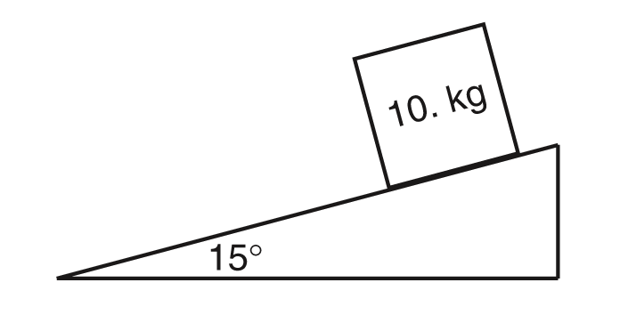

(a) decrease

(b) increase

(c) remain the same.

1. Two carts are pushed apart by an expanding spring as shown below. If the average force on the 1-kilogram cart is 1 newton, what is the average force on the 2 kilogram cart?

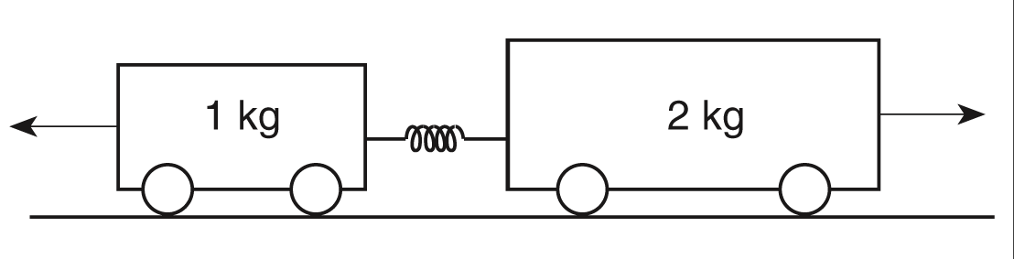

(a) 1 N (b) 0.5 N

(c) 0.0 N (d) 4 N

1. Compared to the force needed to start sliding a crate across a rough level floor, the force needed to keep it sliding once it is moving is

(a) greater

(b) less

(c) the same

1. A 400 N girl standing on a dock exerts a horizontal force of 100 newtons on a sailboat that weighs 10,000 N as she pushes it away from the dock with constant velocity. How much force does the sailboat exert on the girl?

(a) 25 N (b) 400 N

(c) 100 N (d) 10,000 N

1. A satellite weighs 200 newtons on the surface of Earth. What is the satellite’s mass on the surface of the moon?

(a) 200 N (b) 20 N

(c) 20 kg (d) 200 kg

1. The diagram below shows a 5.00 kilogram block at rest on a horizontal, frictionless table.

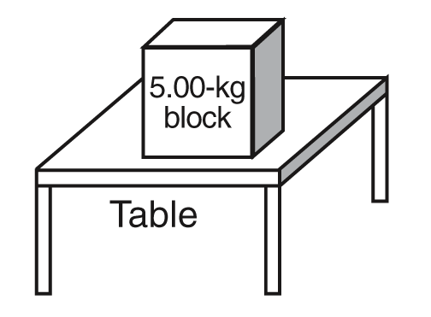

1. If a person gets onto an elevator and the elevator begins to accelerate upward, which of the following statements must be true?

(a) The normal force that the elevator floor exerts on the person is less than the person’s weight.

(b) The normal force that the elevator floor exerts on the person is equal to the person’s weight.

(c) The normal force that the elevator floor exerts on the person is greater than the person’s weight.

1. A box is pushed toward the right across a floor. The force of friction on the box is directed toward the

(a) left (b) ceiling

(c) right (d) floor

Which diagram best represents the force

exerted on the block by the table?

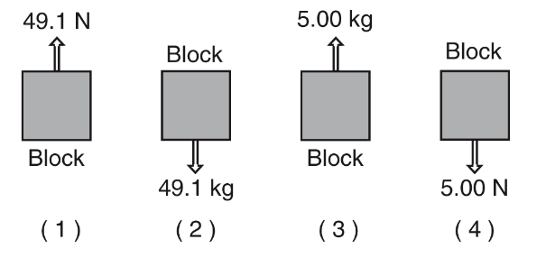

1. A lab cart is loaded with different masses and moved at various constant velocities. Which diagram shows the cart-mass system with the greatest inertia?

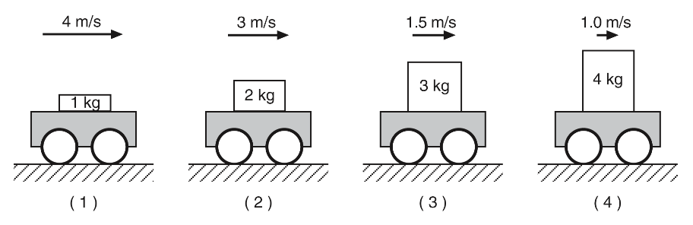

1. *Skip this question* The diagram below shows a sled and rider sliding down a snow-covered hill that makes an angle of 30.° with the horizontal.

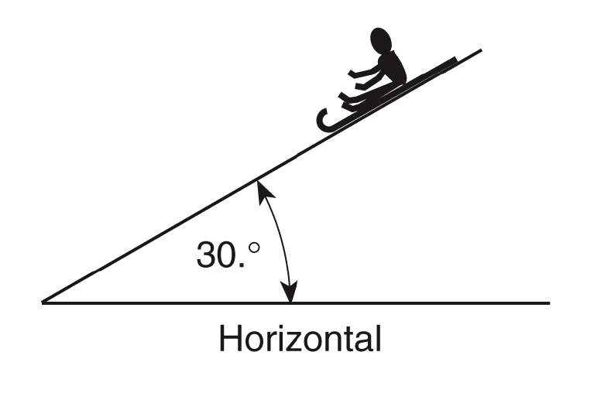

Which vector best represents the direction of the normal force, *FN*, exerted on the sled?

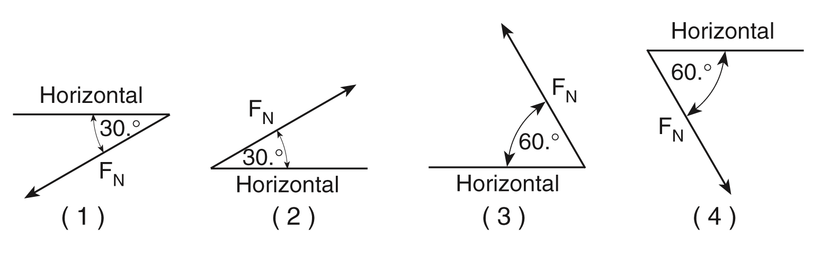

## Short Answer Questions/Problems

1. The coefficient of static friction between an 80 kg crate and a level warehouse floor is 0.400. How much horizontal force would it take to get the crate to begin to slide?
2. You and a friend decide to go bowling. There are two bowling balls sitting in the rack, one black and the other blue. You walk up to the two balls and push them. You then tell your friend that the black bowling ball has more mass than the blue ball. Your friend walks up to the balls and picks them up and then says, “You’re right, but how did you know without picking them up?” Explain based on your understanding of Newton’s Laws.
3. A 60 kg person stands on a bathroom scale in a motionless elevator. When the elevator begins to move, the scale briefly reads 441N. Calculate the acceleration of the elevator. What direction is it moving in?
4. *Optional* A 0.140 kg baseball traveling 45 m/s strikes the catcher’s mitt, which recoils horizontally backward 0.011 m as it brings the ball to rest. What was the force applied on the ball from the glove? (Hint: Use one of the motion equations to find acceleration. Then use Newton’s 2nd law to find the horizontal force on the ball. Ignore vertical forces for this problem)
5. A 6.0 kg bucket is hanging by a massless cord. (a) If the bucket is at rest, what is the tension in the cord? (b) If the bucket is pulled upward with an acceleration of 1.60 m/s2 by the cord, calculate the tension in the cord.
6. A 14-kg box is being pushed by a loading truck in the warehouse. The coefficient of friction (µ) between the box and the warehouse floor is 0.15. How much force is needed to keep the box moving at a constant velocity across the floor?
7. A college students exerts a horizontal force of 8 N on a bag of laundry as he drags it down the hall accelerating at a rate of 0.5 m/s2. If the bag has a mass of 1.5-kg, what is the coefficient of kinetic friction (µ) between the laundry bag and the floor?
8. *Honors Only* An 18.0 kg box is pulled by a rope that makes a 37° angle to the horizontal and moves along the ground at a constant velocity. The tension in the rope is 60N. (a) Find the normal force on the box. (b) Find the coefficient of friction between the box and the ground.

**Answers**

1. A
2. A
3. B
4. C
5. C
6. 1
7. c
8. a
9. 4
10. 3
11. more than 313.6 N
12. The more massive ball required more force to accelerate, Newton’s second law.
13. -2.45 m/s2 down
14. 1289 N
15. (a) 58.8 N; (b) 68.4 N
16. FN = 58.8N, FA = 68.4N
17. FN = 137.2N, FA=20.6N
18. (a) 140 N; (b) 0.34